
PATUAKHALI SCIENCE AND TECHNOLOGY UNIVERSITY
COURSE CODE CIT-112

SUBMITTED TO:

Md. Mahbubur Rahman

Department of Computer Science and Information Technology
Faculty of Computer Science and Engineering
SUBMITTED BY:
Md. Sharafat Karim
ID: 2102024,
Registration No: 10151
Faculty of Computer Science and Engineering
Date of submission: 30 May, 2023
Assignment: 06 (Basic Code)
Table of Contents
1) Reversing digits 3
2) Euler’s Number 4
3) Functions calculate 5
4) Present value 7
5) Square of character S 9
6) sin(x) graph function 11
7) S square with middle O 13
8) postivie values 14
9) Colored line 15
10) Pattern pyramid center aligned 16
11) Pattern of floating island 18
12) Sum of the digits 20
13) left sided pattern 21
14) Fibonacci numbers 22
15) Investment equation 23
16) pattern with for loop 25
17) Age range 27
18) 2 curves 29
19) exponent table 32
20) S writing with loop 34

1) Reversing digits

#include<stdio.h>
int main()
{
int n;
scanf("%d", &n);
int reverse=0;
while (n>0)
{
reverse *= 10;
reverse += n % 10;
n /= 10;
}
printf("%d", reverse);
}
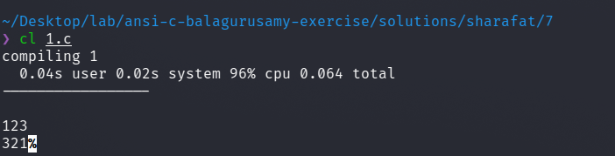

2) Euler’s Number
#include <stdio.h>
int main()
{
float accuracy = 0.00001;
float result=1, sum = 1;
int i = 1;
while ( sum > accuracy )
{
result += sum;
i++;
sum *= ((float)1/i);
}
printf("Result -> %f", result);
}
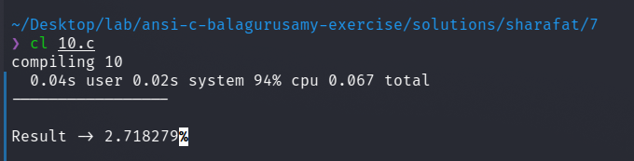

3) Functions calculate
#include <stdio.h>
#include <math.h>
int main()
{
float accuracy = 0.0001, x;
scanf("%f", &x);
float result=1, sum = x;
int i = 1;
while ( sum > accuracy || sum < 0 )
{
result += sum;
i += 2;
sum *= (-1)*(x*x)/(i*(i-1));
if (i >= 100)
break;
}
printf("sinx -> %f\n", result);
result=1, sum = 1;
i = 0;
while ( sum > accuracy || sum < 0 )
{
result += sum;
i += 2;
sum *= (-1)*(x*x)/(i*(i-1));
if (i >= 100)
break;
}
printf("cosx -> %f\n", result);
result=1, sum = 1;
i = 0;
while ( sum > accuracy || sum < 0 )
{
result += sum;
i += 1;
sum *= pow(((float)1/i),i);
if (i >= 100)
break;
}
printf("SUM -> %f\n", result);
}
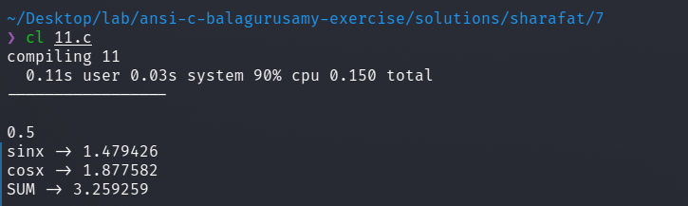

4) Present value
#include <math.h>
#include <stdio.h>
#include <ctype.h>
int input(char name)
{
int n;
printf("Enter the value of %c\n", name );
scanf("%d", &n);
if (n >= 0)
return n;
else
{
printf("Invalid input! Please try again\n");
printf("Value of P is -> %d", n);
return input(name);
}
}
int main()
{
int n, c, d;
c = input('c');
d = input('d');
n = input('n');
int P;
P = c * pow(( 1 - (int)(d/100) ), n);
printf("Value of P is -> %d", P);
return 0;
}
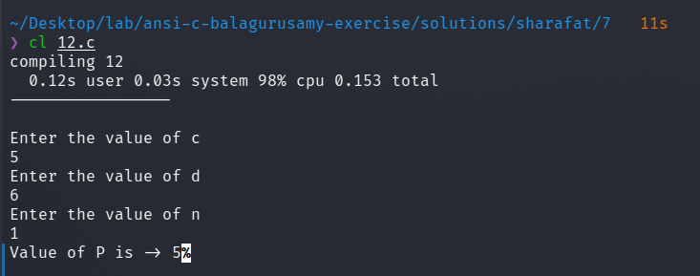

5) Square of character S
#include<stdio.h>
int main()
{
int i, j;
int col = 5;
char Char = 'S';
for (i=0; i< col; i++)
{
for (j=0; j<col; j++)
{
printf("%c ", Char);
}
printf("\n");
}
printf("\n");
for (i=0; i< col; i++)
{
for (j=0; j<col; j++)
{
if (i==0||j==0||i==col-1||j==col-1)
printf("%c ", Char);
else
printf(" ");
}
printf("\n");
}
}
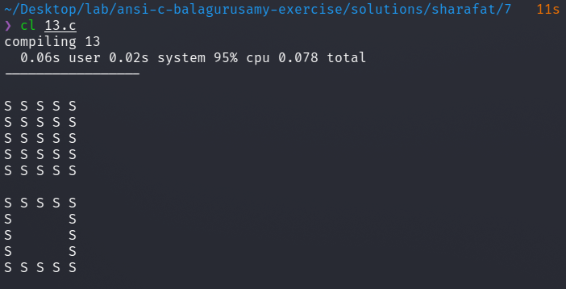

6) sin(x) graph function
#include <stdio.h>
#include <math.h>
/*
x y
--------------------------
0 0.000000
15 0.258819
30 0.500000
45 0.707107
60 0.866025
75 0.965926
90 1.000000
105 0.965926
120 0.866025
135 0.707107
150 0.500000
165 0.258819
180 0.000000
*/
#define PI 3.14159265
int main()
{
int i;
float j, s;
for (j=1.1; j >= 0; j-=0.1)
{
for (i=0; i<= 180; i+= 15)
{
s = sin(i*PI/180);
if (fabsf(s-j)<=0.1)
{
printf("*");
}
else {
printf(" ");
}
}
printf("\n");
}
}
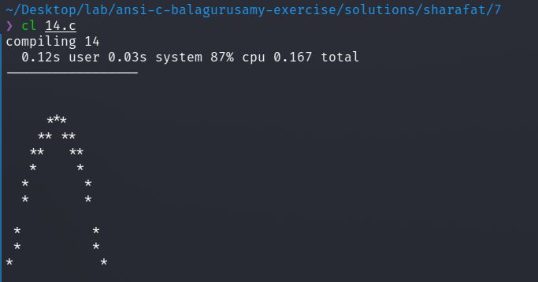

7) S square with middle O
#include<stdio.h>
int main()
{
int i, j;
int col = 5;
char Char = 'S';
char Char2 = 'O';
for (i=0; i< col; i++)
{
for (j=0; j<col; j++)
{
if (i==j && i==2)
printf("%c ", Char2);
else
printf("%c ", Char);
}
printf("\n");
}
}
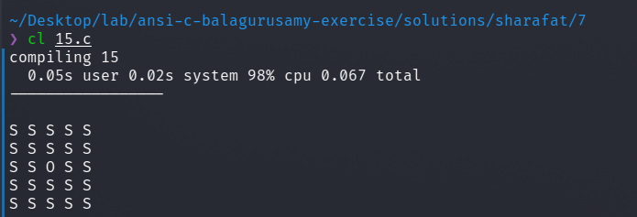

8) postivie values
#include<stdio.h>
int main()
{
int i, j;
int sum=0;
for (i=0; i< 10; i++)
{
scanf("%d", &j);
sum += j;
printf("%d + ", j);
}
printf("\nSum -> %d", sum);
}
// test case
// 1 2 3 4 5 6 7 8 9 10

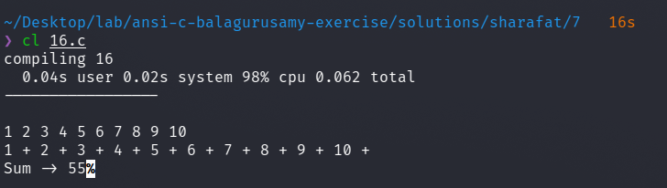

9) Colored line
#include <stdio.h>
void red () {
printf("\033[1;31m");
}
void yellow() {
printf("\033[1;33m");
}
void reset () {
printf("\033[0m");
}
int main () {
red();
printf("Hello ");
yellow();
printf("world\n");
red();
printf("---------------------------\n");
reset();
return 0;
}

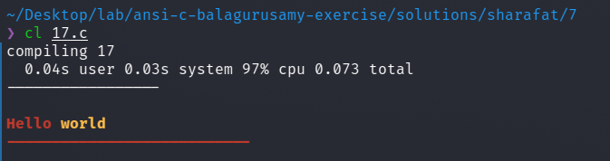

10) Pattern pyramid center aligned
#include<stdio.h>
int main()
{
int i, j;
int digit=1;
char letter='A';
int n;
scanf("%d", &n);
for (i=0; i< n; i++)
{
for (j=0; j<(5-i);j++)
printf(" ");
for (j=0; j<= i; j++)
{
if (i%2==0)
printf("%d ", digit++);
else
printf("%c ", letter++);
}
printf("\n");
}
}
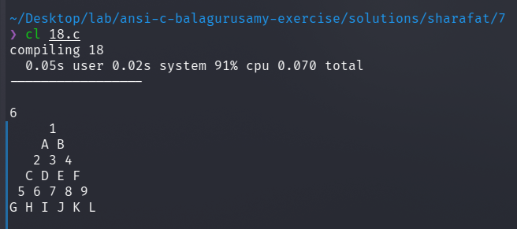

11) Pattern of floating island
#include<stdio.h>
int main()
{
int i, j;
int digit=1;
char letter='A';
int n;
scanf("%d", &n);
for (i=0; i< n/2; i++)
{
for (j=0; j<(5-i);j++)
printf(" ");
for (j=1; j<= i+1; j++)
printf("%d ", j);
for (j=j-2;j>=1;j--)
printf("%d ", j);
printf("\n");
}
for (i=n/2; i>= 0; i--)
{
for (j=0; j<(5-i);j++)
printf(" ");
for (j=1; j<= i+1; j++)
printf("%d ", j);
for (j=j-2;j>=1;j--)
printf("%d ", j);
printf("\n");
}
}
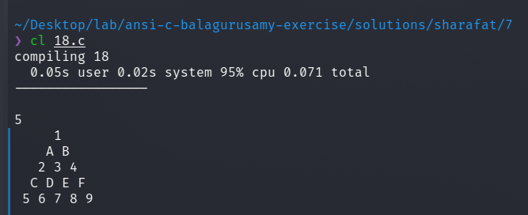

12) Sum of the digits
#include<stdio.h>
int main()
{
int n;
scanf("%d", &n);
int sum=0;
while (n>0)
{
sum += n % 10;
n /= 10;
}
printf("%d", sum);
}
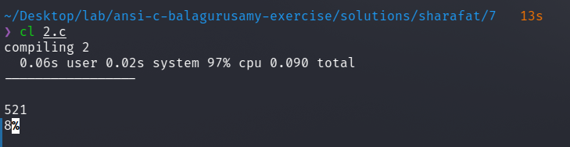

13) left sided pattern
#include<stdio.h>
int main()
{
int i, j;
int digit=1;
char letter='A';
int n;
scanf("%d", &n);
for (i=0; i< n; i++)
{
for (j=0; j<= i; j++)
printf("%d ", ((i+j)%2==0?1:0));
printf("\n");
}
}
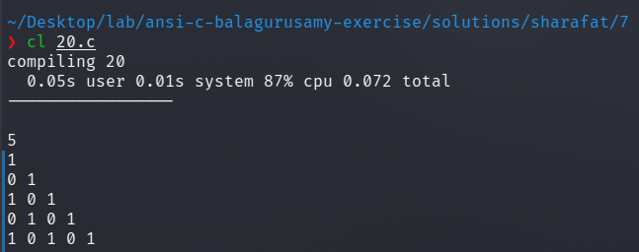

14) Fibonacci numbers
#include<stdio.h>
int main()
{
int n;
scanf("%d", &n);
int i=0, j=1, k=1, l=0, sum=0;
do
{
if ( i == 0 || i == 1 )
sum += 1;
else
{
sum += j + k;
l = j + k;
k = j;
j = l;
}
i++;
} while (i<n);
printf("%d", sum);
}
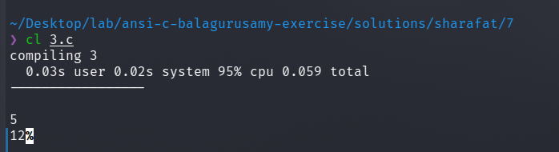

15) Investment equation
#include<stdio.h>
int main()
{
int n=1;
int p=1000, V ; float r=0.10;
do
{
V = p * (1+r);
printf("P - %d , V - %d , n - %d \n", p, V, n++);
p = V;
} while ( p <= 10000 );
}
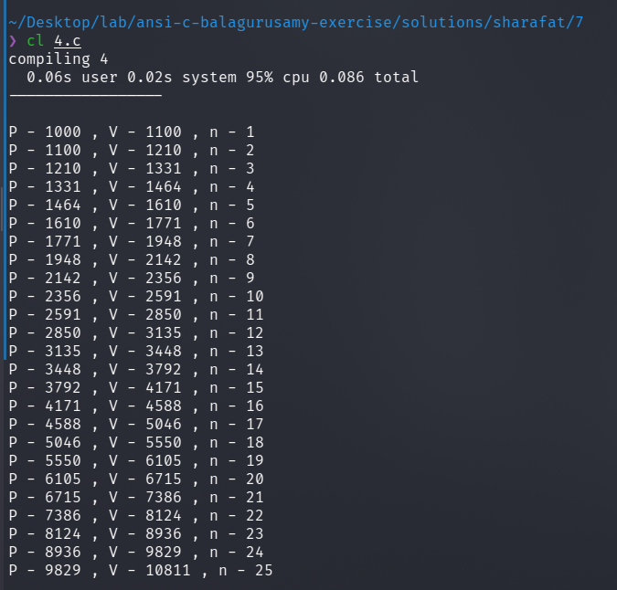

16) pattern with for loop
#include <stdio.h>
int main()
{
int n;
scanf("%d", &n);
int i, j;
for (i=0; i<n; i++)
{
for (j=1; j<=i+1; j++)
printf("%d ", i+1);
printf("\n");
}
printf("\n");
for (i=0; i<n; i++)
{
for (j=0; j<i; j++)
printf(" ");
for ( j=n-i ; j>0 ; j-- )
printf("* ");
printf("\n");
}
}
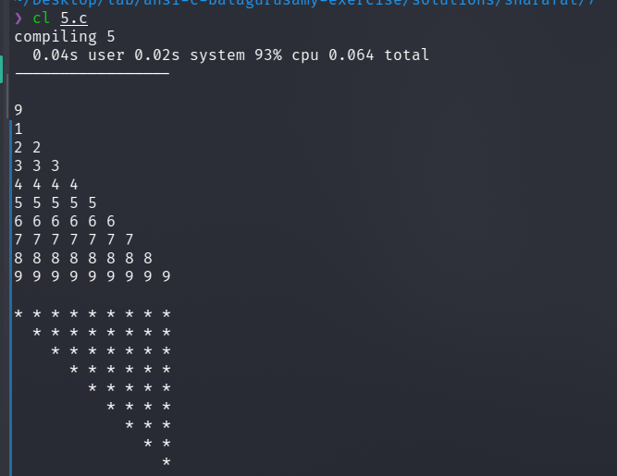

17) Age range
#include<stdio.h>
int main()
{
int i, j;
int sum = 0;
for (i=0; i<100; i++)
{
scanf("%d", &j);
if ( 50 <= j && j <= 60 )
{
sum++;
continue;
}
}
printf("total - %d", sum);
}
// test cases
// 84 29 50 5 96 36 47 77 16 30 39 79 63 40 19 76 42 57 97 48 69 24 98 55 73 3 25 60 92 46 26 44 23 95 65 45 15 59 62 51 85 20 71 87 31 4 8 66 99 7 54 89 37 6 70 1 56 81 75 90 2 17 28 88 14 11 82 18 94 13 49 22 61 9 10 21 64 32 91 67 58 33 93 38 83 34 12 41 78 72 27 74 80 43 68 86 35 100 53 52
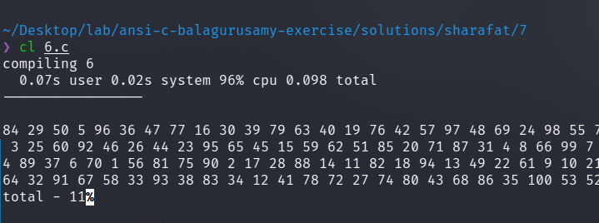

18) 2 curves
#include<stdio.h>
#include <math.h>
int main()
{
int i;
float a, x, y1, y2;
a = 0.4;
printf(" y --------> \n");
printf("-------------------------------------\n");
for (x=0; x<5; x= x + 0.25)
{
y1 = (int) (50*exp(-a * x)+0.5);
y2 = (int) (50*exp(-a * x + x/2)+0.5);
if (y1 == y2)
{
if (x==2.5)
printf(" X |");
else
printf("|");
for (i=1; i <= y1-1; ++i)
printf(" ");
printf("#\n");
continue;
}
if (y1>y2)
{
if ( x == 2.5 )
printf(" X |");
else
printf(" |");
for (i=1; i <= y2-1; ++i )
printf(" ");
printf("*");
for ( i = 1; i <= (y1 - y2-1);++i)
printf("-");
continue;
}
if (x==2.5)
printf(" X |");
else
printf(" |");
for (i = 1; i <= (y1 - 1); ++i)
printf(" ");
printf("0");
for (i = 1; i <= (y2-y1-1); ++i)
printf("-");
printf("*\n");
}
printf(" |n");
float j, s;
for (j=1.1; j >= 0; j-=0.1)
{
for (i=0; i<= 5; i+= 0.5)
{
s = exp(-a * x);
if (fabsf(s-j)<=0.1)
{
printf("*");
}
else {
printf(" ");
}
}
printf("\n");
}
}
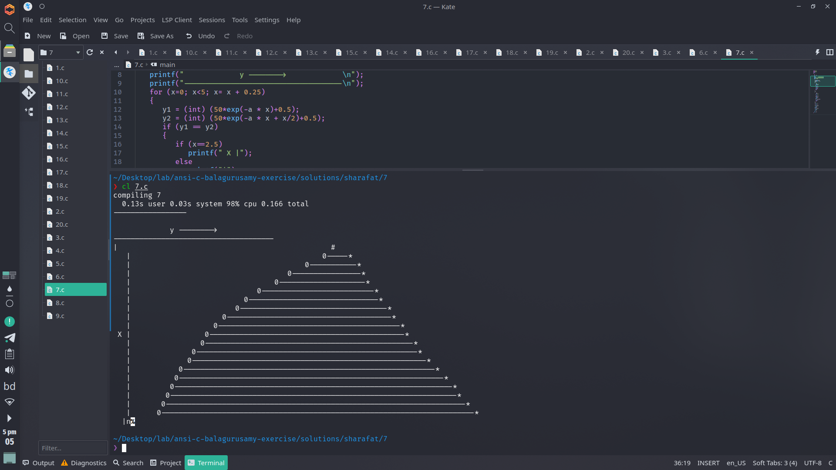

19) exponent table

#include<stdio.h>
#include <math.h>
int main()
{
float x, y;
x = 0.0;
float i, j;
for (i=0; i<= (float)(0.91) ; i += 0.1)
{
if (i==0)
printf(" X ");
else
printf(" %.1f ", i);
}
printf("\n");
for (i=0; i<= 9 ; i += 1)
{
for (j=i; j<=i+0.91; j += 0.1)
{
if (j==i)
printf(" %.1f ", j);
else
printf(" %.1e ", exp(-j));
}
printf("\n");
}
printf("\n");
}
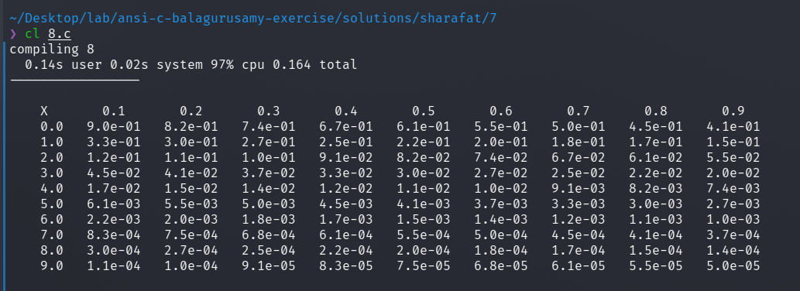

20) S writing with loop
#include <stdio.h>
int main() {
int rows = 15;
int cols = 18;
int i, j;
for (i = 0; i < cols; i++)
printf("*");
printf("\n");
for (i = 0; i < cols; i++)
{
if (i < 2 || i > 15)
printf("*");
else
printf("-");
}
printf("\n");
for (i = 0; i < cols; i++)
{
if (i < 9 || i > 15)
printf("*");
else
printf("-");
}
printf("\n");
for (i = 0; i < cols; i++)
{
if (i < 4 )
printf("*");
}
printf("\n");
for (i = 0; i < cols; i++)
{
if (i < 4 )
printf("*");
}
printf("\n");
for (i = 0; i < cols; i++)
{
if (i < 4 )
printf("*");
}
printf("\n");
for (i = 0; i < cols; i++)
{
if (i < 5 || i > 13)
printf("*");
else
printf("-");
}
printf("\n");
for (i = 0; i < cols; i++)
{
if (i > 13)
printf("*");
else
printf("-");
}
printf("\n");
for (i = 0; i < cols; i++)
{
if (i > 13)
printf("*");
else
printf("-");
}
printf("\n");
for (i = 0; i < cols; i++)
{
if (i > 13)
printf("*");
else
printf("-");
}
printf("\n");
for (i = 0; i < cols; i++)
{
if (i > 13)
printf("*");
else
printf("-");
}
printf("\n");
for (i = 0; i < cols; i++)
{
if (i > 13)
printf("*");
else
printf("-");
}
printf("\n");
for (i = 0; i < cols; i++)
{
if (i > 13)
printf("*");
else
printf("-");
}
printf("\n");
for (i = 0; i < cols; i++)
{
if (i < 4 || i > 13)
printf("*");
else
printf("-");
}
printf("\n");
for (i = 0; i < cols; i++)
{
if (i < 3 || i > 13)
printf("*");
else
printf("-");
}
printf("\n");
for (i = 0; i < cols; i++)
{
if (i < 2 || i > 13)
printf("*");
else
printf("-");
}
printf("\n");
return 0;
}

